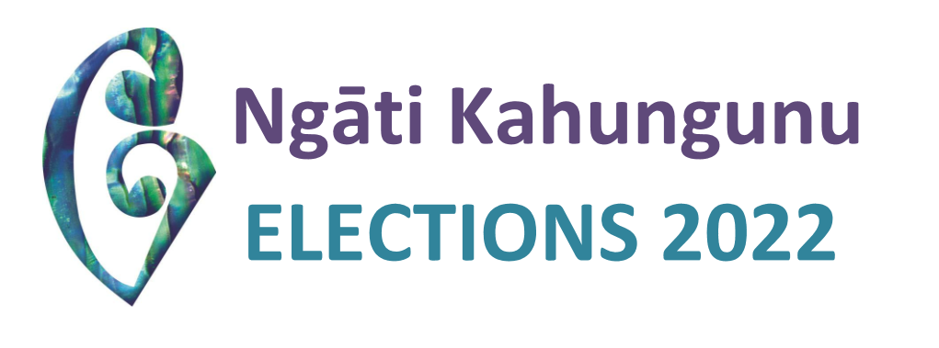

Nominations for the Ngāti Kahungunu Iwi Incorporated Iwi triennial Board Elections closed today Monday 28 February at 12noon giving all eligible applicants ample time to indicate their interest and submit their nomination forms. Congratulations to those candidates who have put themselves forward. The following list shows that there will be an election for the following positions, Chairperson, Kaumātua, Kahungunu ki Wairarapa and Ngati Kahungunu Wairoa Taiwhenua. The other positions that have one candidate will successfully go through unopposed.

**Successful Candidates**

|  |  |
| --- | --- |
| POSITION | CANDIDATE |
| Chairman | BARBER, Bayden  TOMOANA, Ngahiwi |
| Kaumātua | HAPUKU, Owen Jerry  HILTON, Haami Te Kuru |
| Ngāti Kahungunu Wairoa Taiwhenua | HOW, Nigel  WILSON, Naomi |
| Taurahere Northern District | BEATTIE, Eruera  *(unopposed)* |
| Taurahere Southern District | RUAWAI-HAMILTON, Brian  *(unopposed)* |
| Te Taiwhenua o Heretaunga | HOKIANGA, Thompson  *(unopposed, no alternate)* |
| Te Taiwhenua o Tamatea | HEPERI-SMITH, JB  *(unopposed, no alternate)* |
| Te Taiwhenua o Te Whanganui-a-Orotū | RETI, George  *(unopposed, no alternate)* |
| Kahungunu ki Tāmaki-nui- a-Rua | HAPE, Hayden  *(unopposed, no alternate)* |
| Kahungunu ki Wairarapa | IHAKA, Melissa  RUTENE, Andrea  WAIPUKA, Jennishavorne |

**Iwi Board Diagram**



**Election Timeline**

See below the timeline for this election.. Registrations for this election close on 19 April 2022, allowing administrative staff to ensure data is entered and voting forms are able to be sent out to these members. However, we encourage you to update or register as soon as possible.

* 28 February     NOMINATIONS CLOSE – CANDIDATES ADVERTISED
* 24 March         VOTING MAILERS SENT OUT WITH PROFILES
* 19 April            NKII REGISTRATIONS CLOSE FOR ELECTION ADMINISTRATION PURPOSES
* 26 April            ELECTION DAY – VOTING CLOSES
* 26 April            SPECIAL GENERAL MEETING
* 2 May              DECLARATION OF RESULTS
* 20 May            NEW BOARD MEMBERS WILL BE INTRODUCED AT THEIR FIRST BOARD HUI

**Contact Us**

**For all Registration inquiries or to udate your information:**

Contact the Registration Officer: Kerrin Fair – [kerrin@kahungunu.iwi.nz](mailto:kerrin@kahungunu.iwi.nz) or phone toll free 0800 524 864 ext 1

**To inquire about the election process:**

Contact the Independent Returning Officer: Dale Ofsoske of Election Services – [dale@electionservices.co.nz](mailto:dale@electionservices.co.nz) or phone toll free 0800 922 822

**To keep informed and join the iwi communication network:**

Contact the iwi Communications Advisor: Ruth Wong – [ruth@kahungunu.iwi.nz](mailto:ruth@kahungunu.iwi.nz)

To learn more about the Election Process visit our website: <https://www.kahungunu.iwi.nz/nkiiboardelection2022>